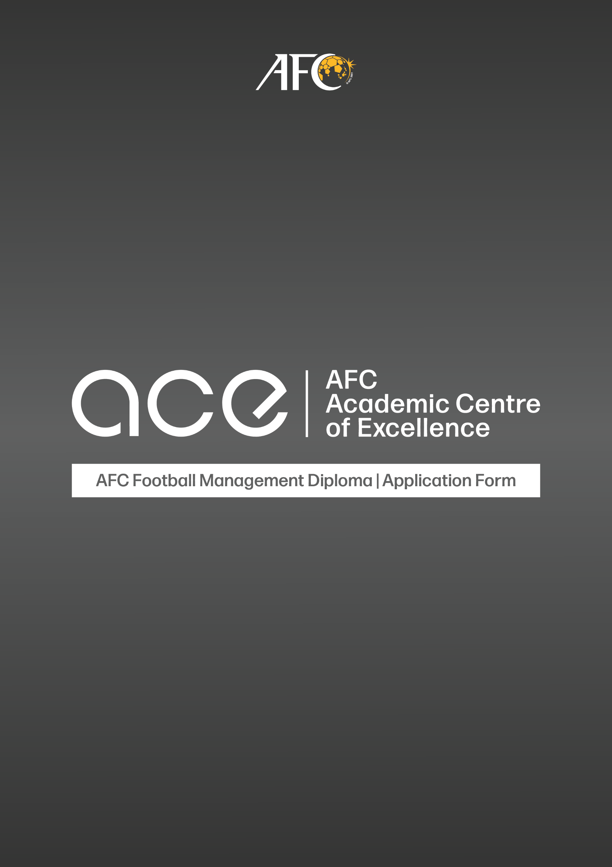

Please fill in and submit this application form together with your curriculum vitae (CV), a copy of your passport (personal information page), and copies of your education certificates to the AFC (via email at: academy@the-afc.com) no later than 13 January 2023. Applications received after this deadline will not be accepted.

1. Personal details

Passport size photograph
First name :
Surname :
Nationality :
Date of birth : (DD/MM/YYYY)

Gender : Male Female
Passport No. :
Home address :
Email address :
Mobile Number :

2. Employer details
Name :
Address :
Telephone number :
Email address :

3. Roles, responsibilities and professional achievements in organisation
Current position / title :
Department :
Division / unit :
Date joined : (DD/MM/YYYY)

Type of employment : Permanent Contract Part-time

If contract, validity period: _________________________

Roles and responsibilities of the above-mentioned position / title:
Role | Responsibilities | Deliverables
Professional Achievements (please indicate if not applicable)
*Add rows if necessary

Previous position / title within organisation: Applicable Not Applicable
Position / title :
Date joined : (DD/MM/YYYY)
Roles and responsibilities :

4. Work experience
Describe your previous working experiences before joining this organisation
Organisation | Position / title | Year of service | Responsibilities
*Add rows if necessary

5. Academic / Professional Qualifications
Academy Institution | City & Country | Dates attended | Qualification
*Add rows if necessary

Have you enrolled in a similar Education Programme? If yes, please indicate below:

Academy Institution | City & Country | Dates attended | Qualification

6. English language proficiency
Please tick whichever is applicable:
Written English | Beginner Intermediate Advanced
Spoken English | Beginner Intermediate Advanced
Practice of English | Daily Weekly Monthly Never
Internationally recognised English qualifications | Yes No  If yes, please complete the following:  a) Name of English qualification:  b) Accredited / endorsed by:  c) Commencement & completion Date:  d) Certificate of completion (score / grade):

7. IT proficiency
Usage of online platforms previously | Yes No
Understanding and usage of IT | Beginner Intermediate Advanced
Access to internet connection in home country | Yes No

8. Referral

1. Name :
Address :
Telephone number :
Email address :
Relationship :

2. Name :
Address :
Telephone number :
Email address :
Relationship :

9. Additional information

Please answer the following questions.

a) Why do you wish to enrol in the AFC Football Management Diploma Programme? What are your objectives and learning outcomes? (Max 200 words)

b) What qualifies you to undertake the programme? (Max 150 words)

c) Please provide details on how your enrolment in this programme will benefit you, your organisation and the Asian Football Confederation? (Max 150 words)

10. Declarations

Applicant’s declaration
I hereby confirm the details furnished above are true and accurate to the best of my knowledge and belief. I understand that a false statement or falsified document may disqualify me from being selected for the AFC Football Management Diploma programme. Should I gain admission, I will ensure full commitment to the programme for the interest of all parties.

Name
Designation
Signature
Date (DD/MM/YYYY)

Organisation / Representative Declaration
I acknowledge and confirm the details provided by Mr. / Ms. ______________________________ are true and correct and we have agreed and approved to nominate him / her to apply for the AFC Football Management Diploma programme. Should the application be successful, we undertake full commitment to ensure our applicant(s) abides with all the rules and regulations set by the AFC throughout the programme. We agree to be bound by the terms of this declaration.

Approved by Representative of Organisation:
Printed Name and Date | Signature
Organisation stamp (if any)

* Please take note that if the applicant is selected, the successful candidate will need to sign a declaration of commitment form with the AFC.

